- In an unexpectedly tight vote, the Bank of England opted to cut Bank Rate by 25bps to 4% today. At the same time, the Monetary Policy Committee raised its inflation forecasts. Although we still expect another 25bps cut in November, our call is made with much less confidence.
- The MPC's messaging has been inconsistent this year. Worries about labour market fragility have eased since June's very dovish minutes. The MPC's focus has now returned to the degree to which services inflation is cooling in response to labour market developments, and the impact of higher food and fuel prices on inflation expectations.
- Meanwhile, the BoE's review of quantitative tightening found the programme hasn't affected market functioning and is having a limited impact on gilt yields. But the acknowledgment the risks could be greater in future is consistent with our view that the MPC is likely to reduce the pace of QT at next month's meeting and focus its sales more on short- and medium-dated gilts.
The Bank of England's Monetary Policy Committee voted to cut Bank Rate by 25bps to 4% at today's meeting. But the committee was only able to reach a majority after a second round of voting. Initially, one member voted for a 50bps cut, four members for a 25bps cut, and four for no change. The second vote with only an unchanged rate or a 25bp reduction as options was 5-4 for the cut.
The voting pattern was more hawkish than we anticipated, with Clare Lombardelli and Megan Greene joining Huw Pill and Catherine Mann in voting for no change. Their switch to voting to hold rates appears to have been motivated by concerns that recent high inflation could raise inflation expectations among households and firms. Over the next 18 months, the MPC's new forecast projects inflation on average 0.4ppts higher than its May estimate (Chart 1).
That these moves are being driven by stronger price pressures in the highly salient food and fuel categories appears to have magnified the concerns of the more hawkish group. Some of those who voted to cut were also sympathetic to these concerns.
Chart 1: The BoE expects inflation to be much higher in the next 18 months before settling at 2%
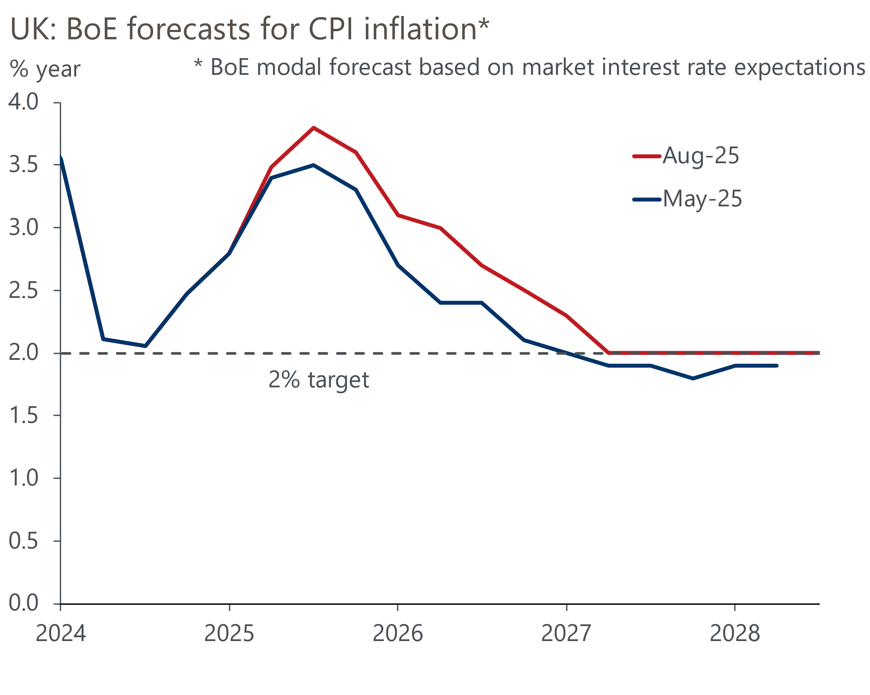
Source: Bank of England Monetary Policy Report

At the same time, data revisions appear to have eased concerns about the fragility of the labour market, while the strength of the link between wage growth and domestic prices is also a source of debate for some members.
Still, the MPC's new forecast implicitly validates the market curve, which suggests a further reduction in rates of just over 50bps over the next year (Chart 2). Based on this interest rate profile, the MPC's new forecast still shows inflation dropping back in line with the 2% target in two years and remaining there. The minutes also repeated the line that "a gradual and careful approach to the further withdrawal of monetary policy restraint remained appropriate."
Chart 2: The BoE's forecasts implicitly validated market expectations of two more 25bps cuts
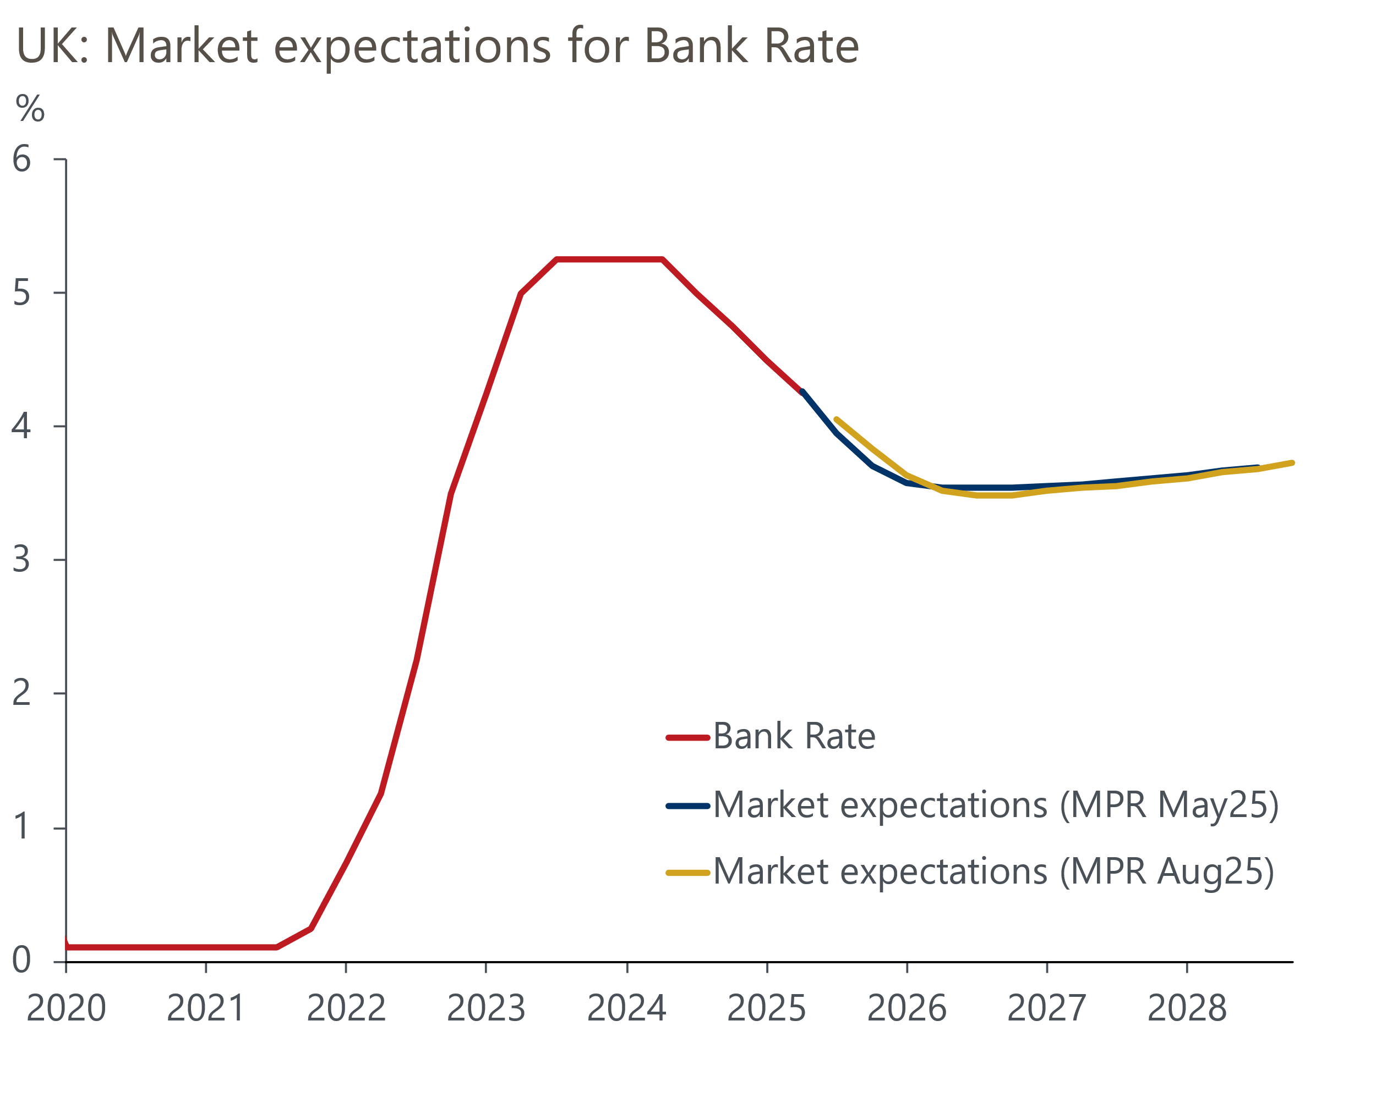
Source: Bank of England Monetary Policy Report
Since the start of the rate easing cycle, the MPC has cut at alternate meetings, so September has always looked a likely 'hold' meeting. Whether the committee then cuts again in November will be heavily influenced by the inflation data published in the interim. BoE staff anticipate CPI inflation rising to 4%, with services inflation hitting 5%.
On balance, we maintain our call that the MPC will cut by 25bps in November. We expect inflation to come in broadly in line with the Committee's forecast and think that growth will disappoint. If the Budget takes place before the November meeting, the MPC will likely have to factor in further fiscal tightening into its decision-making. Provided that the intelligence on next year's pay settlements remains consistent with the 3%-3.5% range currently flagged by the BoE's regional agents, we expect a narrow majority for a 25bps cut. But our call is made with much less confidence than before, and we think it wouldn't take much to convince the committee to pause for longer before cutting again. If inflation continues to surprise to the upside, this could tip the balance towards no change, particularly if market pricing moves against a rate cut. With Governor Andrew Bailey now clearly the committee's swing voter, his comments will also prove key.

BoE hints at changes to quantitative tightening next month
The Monetary Policy Report contained the BoE's annual review of the quantitative tightening programme. It concluded that so far, the programme has had no marked impact on market liquidity and only a modest impact on gilt yields. However, there were some subtle hints that the MPC is likely to tweak its approach when it votes on the 2025-2026 target at next month's meeting. The BoE acknowledged that changes in market conditions posed a risk that QT could have a greater impact on market functioning in the future. It also referenced the Debt Management Office's decision to amend its 2025-2026 financing remit by reducing sales of long-term bonds and increasing short-term financing.
We view this commentary as consistent with our call that the MPC will vote for a QT target of £75bn-£80bn, down from the current pace of £100bn a year, and that the BoE will focus active gilt sales on short- and medium-dated gilts rather than longs.

Key passages from the MPC minutes
“Five members preferred a reduction in Bank Rate at this meeting. Four of these five members preferred a 0.25 percentage point reduction in Bank Rate at this meeting. There had been sufficient progress in underlying disinflation albeit, for some of these members, with a risk that this momentum could slow. There remained greater signs of disinflation from labour market quantities and wages, than from developments in domestic prices. Activity remained weak. The pace of disinflation from here would help inform these members’ views on how quickly to remove remaining policy restraint. On the one hand, higher food prices could raise inflation expectations and generate greater inflation persistence. On the other hand, signs of weaker demand, for example as a result of the impact of continued high saving on consumption, could lead to a more rapid opening up of slack in the labour market."
Our interpretation: There appears to be a range of views among those who voted for a 25bps cut. Some – probably including Governor Bailey – had sympathy for some of the arguments of those voting for no change. This suggests there's a low bar to them switching camps at the November meeting.
"One of these five members preferred a 0.5 percentage point reduction in Bank Rate at this meeting. Underlying disinflation continued. Absent external shocks, domestic inflation, especially in services, was tightly linked to wages. The labour market had slack and was deteriorating further. Wage settlements had fallen to around 3.5% in the first half of 2025 and were expected to fall further in the second half. The inflation hump was expected to normalise, being dominated by one-off changes in tax and administered prices, and food inflation in a limited set of items, neither related to demand pressure. Energy futures curves were flat. With a US average tariff rate near 20%, trade diversion would slowly permeate, pushing down on inflation. UK sentiment was weak, with subdued consumption and investment. This picture was one of downside risks in coming years, namely: inflation below forecast, and activity weak or an increased risk of recession. For insurance against this balance of risks, a less restrictive policy was warranted."
Our interpretation: This risk management approach has long been advocated by Alan Taylor, so his initial vote for a larger cut was unsurprising. Arguably more surprising was that Swati Dhingra, consistently the most dovish MPC member in recent years, moved back into line with the majority.
"Four members preferred to hold Bank Rate at 4.25% at this meeting. The disinflationary process had slowed and the risk of inflation expectations feeding through to second-round effects had risen. Business and household inflation expectations remained elevated, inflation was expected to peak at 4% and much of the recent near-term upside news in inflation had been driven by highly salient food and energy prices. Firms’ own-price expectations remained more sensitive to upside inflation surprises as well. These members would continue to assess the pace of disinflation, being alert to downside pressures on pricing power from domestic demand and global forces, alongside the risk of greater inflation persistence from structural changes in goods and labour markets. A slower loosening of policy would reduce the risk of inflation not meeting the target sustainably."
Our interpretation: Greene and Lombardelli's votes to hold were a little surprising. This group seems to be particularly concerned about the impact of recent higher inflation rates, particularly for food and fuel, on inflation expectations. This suggests these members are unlikely to vote for cuts again until they see evidence of inflationary pressures cooling in these categories.
"The Committee judged that a gradual and careful approach to the further withdrawal of monetary policy restraint remained appropriate. The restrictiveness of monetary policy had fallen as Bank Rate had been reduced. The timing and pace of future reductions in the restrictiveness of policy would depend on the extent to which underlying disinflationary pressures would continue to ease. Monetary policy was not on a pre-set path, and the Committee would remain responsive to the accumulation of evidence."
Our interpretation: The committee's broad guidance was unchanged compared with recent months. This suggests that the majority expect to cut interest rates further over the coming months, but they remain very uncertain about the pace of cuts or the terminal rate.

